**Lesson 20: Assessment**

**For each of the following questions, please solve or circle your answer from the given choices. Below the question, please show all the steps you used to find the answer. Then, explain why your answer is correct or why the other answers are wrong.**

**Problem One:**

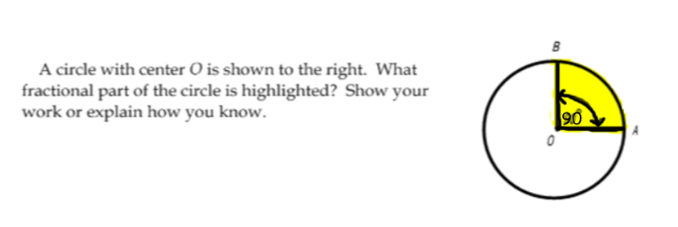

**Steps to get your answer:**

**Justify/explain why your answer is correct or makes sense:**

**Problem Two:**

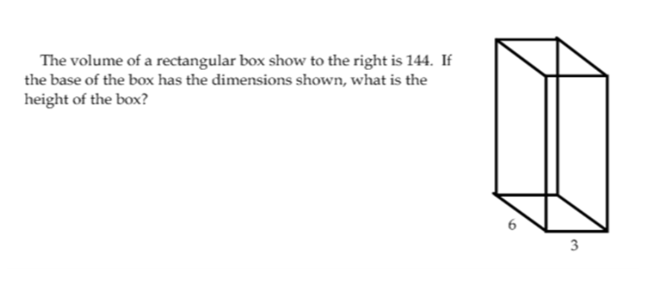

**Steps to get your answer:**

**Justify/explain why your answer is correct or makes sense:**

**Problem Three:**

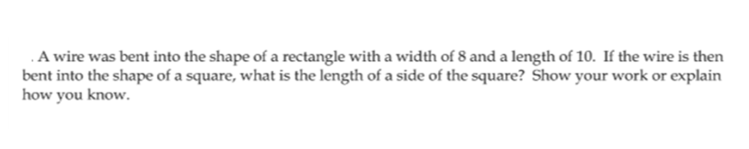

**Steps to get your answer:**

**Justify/explain why your answer is correct or makes sense:**

**Problem Four:**

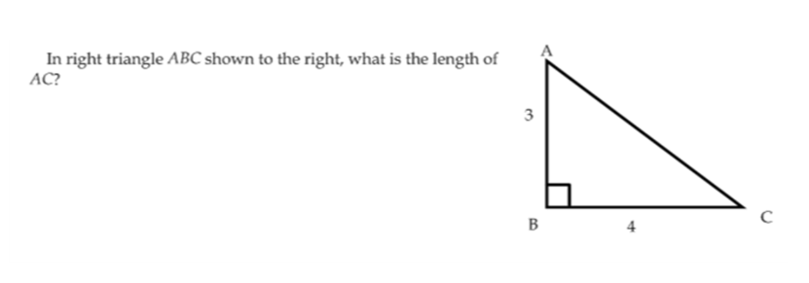

**Steps to get your answer:**

**Justify/explain why your answer is correct or makes sense:**

**Problem Five:**

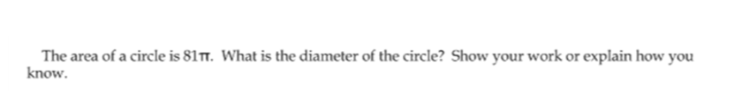

**Steps to get your answer:**

**Justify/explain why your answer is correct or makes sense:**

**Problem Six:**

Josh claims that -51000 will be a negative number because of order of operations. Jack claims that -51000 should be positive because there are an even number of negative numbers being multiplied. Who is right? Justify.

**Steps to get your answer:**

**Justify/explain why your answer is correct or makes sense:**

**Problem Seven:**

The opening of a box is a square that is 10 inches long on each side. I am trying to fit a circle into that square. That circle has an area of 81π. Can the circle fit in the square? Justify your answer, and feel free to provide a drawing!

**Steps to get your answer:**

**Justify/explain why your answer is correct or makes sense:**

**Problem Eight:**

The probability that I pick an Oreo at random from a dessert jar is ½. Let’s say that inside the dessert jar, there are only Oreos and cookies. How many Oreos and how many cookies could there be in the jar? Justify.

**Steps to get your answer:**

**Justify/explain why your answer is correct or makes sense:**

**Problem Nine (extra credit):**

Give a decimal estimate of $\sqrt{13}$. The person in the period who has the closest guess will get two points of extra credit! (everyone else gets nothing).

**Steps to get your answer:**

**Justify/explain why your answer is correct or makes sense:**